The provinces of Canada
Answer the following questions about each of the Canadian provinces. Research answers to the questions.

- Name the province : ___________________________________
- Color the province on a map: 3) Draw the province’s flag:
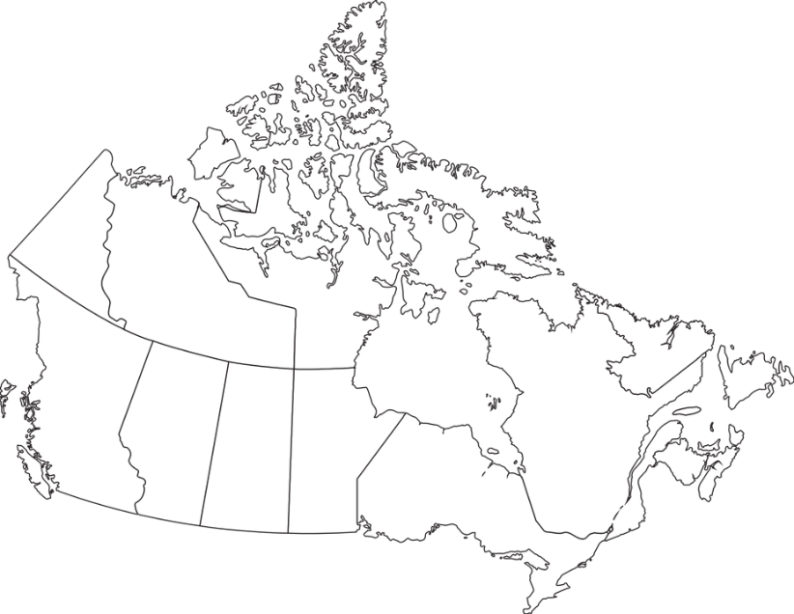
- What is the capital of the province? _________________________
- What is the population of the province? _______________________
- Who is currently the Premier of the province?
_______________________________
- What is the provincial bird? _____________________________
- What is the provincial flower? ____________________________
- Name a natural resource found in this province : ___________________________________________________
- Share a fun fact about this province :
____________________________________________________________

